PEX3 Analysis Report: LRU Page Replacement Simulation
CS 483 — Operating Systems — Spring 2026
Name: Gia Sanchirico Section: M3 Date: 4-23-26

Documentation Statement
I used excel for this and the pex3 assignment instructions to help me create the graphs and the fault line. I also used the lesson 24 slides and textbook chapter to help me understand the data. As well as the textbook chapter 28 to learn more about the working set.

1. Optimum Frame Size Recommendation (4 pts)
To keep the page-fault rate below 10% the 4KB memory would be best. Unlike the other memory sizes, 1KB reached below the 10% fault rate at a minimum of 318 KB (1KB * 318 frames), compared to the other sizes which required minimums of 344KB (512B * 689 frames / 2^10) 358KB (2KB * 179 frames), or 424 (4KB * 106 frames) frames. This occurs because larger frame sizes suffer from internal fragmentation since the page could be wasted if not used completely, thus lowering efficiently and wasting memory. However, smaller frames led to more frequent faults because more frames are used. Therefore 1KB would be the best decision because it requires the lowest memory to drop below the fault rate and would be the most efficient because it is between the largest and smallest frame sizes.

2. Frames Required to Achieve < 10% Page-Fault Rate (4 pts)
For each frame size, identify the minimum number of frames where the page-fault rate first drops below 10%.
Frame Size | Min Frames for < 10% | Fault Rate at That Count
512 B | 689 | 0.099960
1 KB | 318 | 0.099937
2 KB | 179 | 0.099777
4 KB | 106 | 0.099938

3. Frames vs. Number of Page Faults — 4 charts (6 pts)
Insert one chart per frame size showing Frames (x-axis) vs. Number of Page Faults (y-axis). Each chart must have a descriptive title, labeled axes with units, and clean formatting. (1.5 pts per chart)

512 B Frames — Page Faults (1.5 pts)
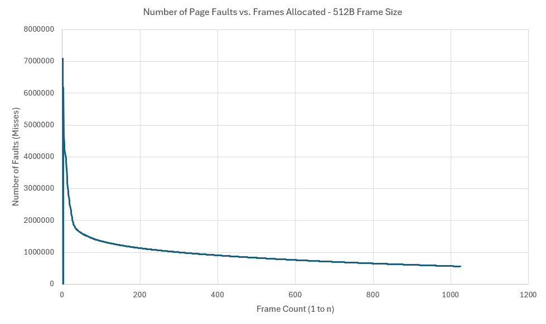

1 KB Frames — Page Faults (1.5 pts)
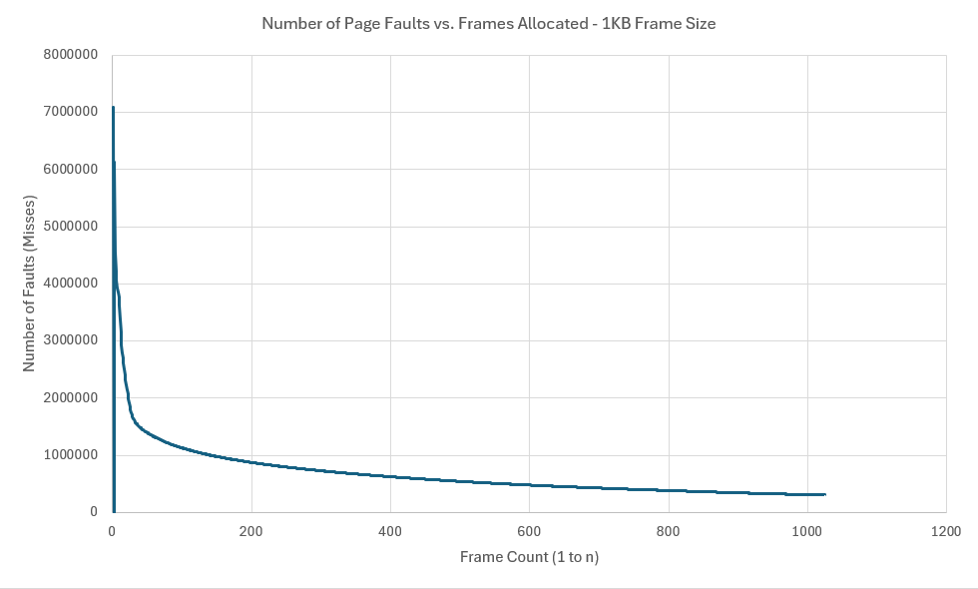

2 KB Frames — Page Faults (1.5 pts)
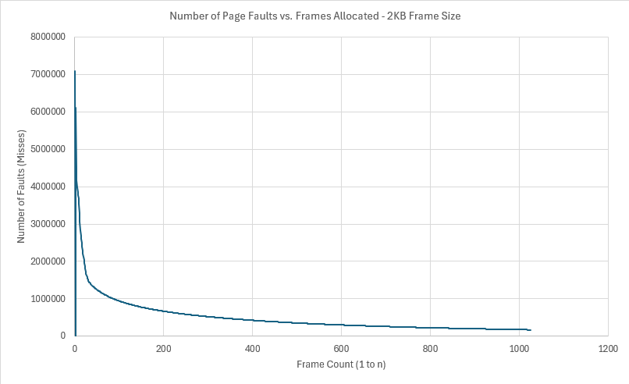

4 KB Frames — Page Faults (1.5 pts)
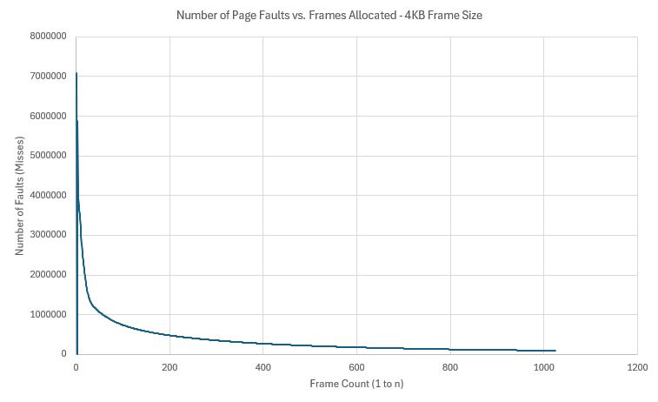

4. Frames vs. Page-Fault Rate — 4 charts (6 pts)
Insert one chart per frame size showing Frames (x-axis) vs. Page-Fault Rate (y-axis). Each chart must include a horizontal reference line at 10% fault rate, descriptive title, and labeled axes. (1.5 pts per chart)

512 B Frames — Fault Rate (1.5 pts)
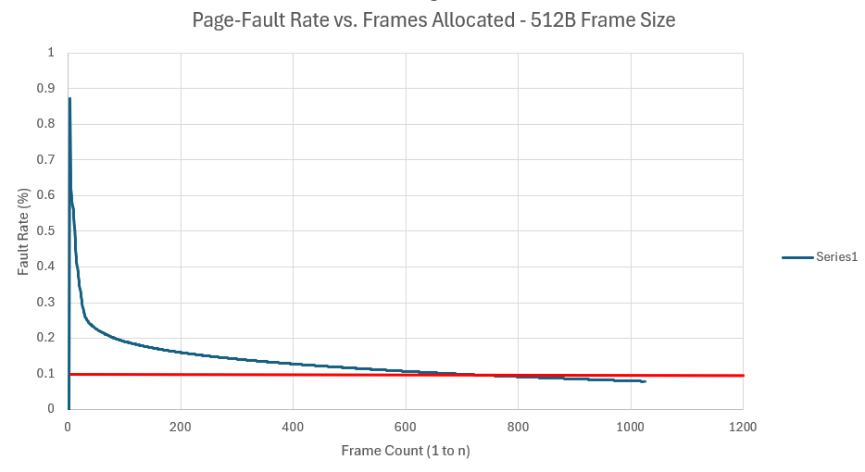

1 KB Frames — Fault Rate (1.5 pts)
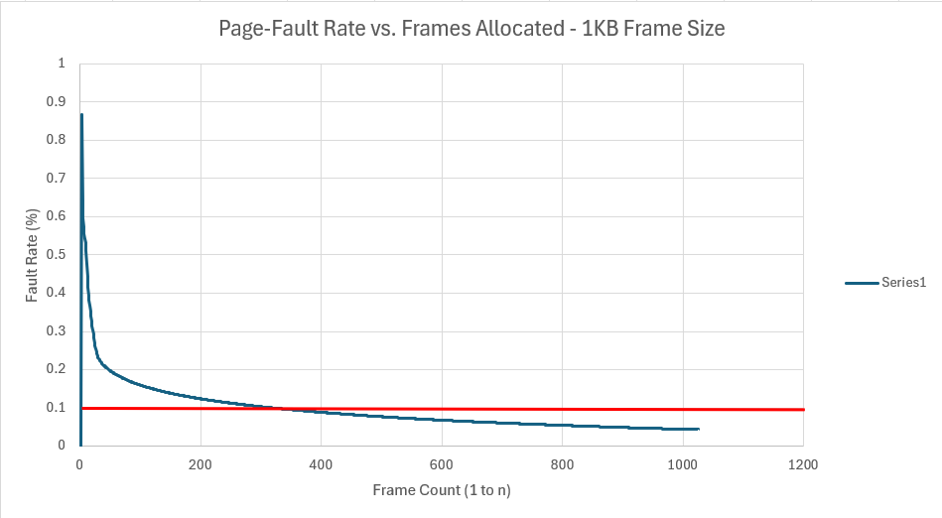

2 KB Frames — Fault Rate (1.5 pts)
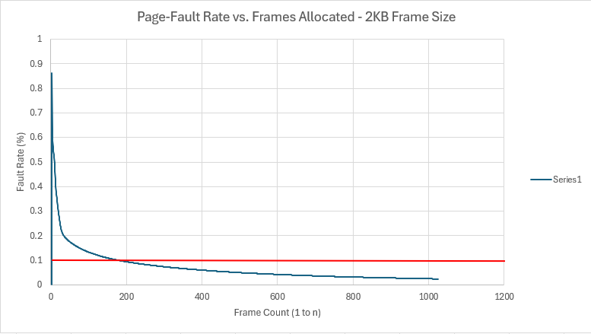

4 KB Frames — Fault Rate (1.5 pts)
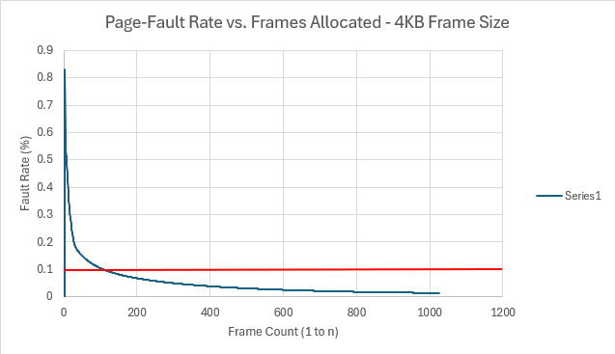

5. Curve Shape and Working Set Analysis (5 pts)
The graphs should a sharp peak at the beginning of the graph around frame 1 and then after reaching a peach at 3 frames, steeply decline until gradually flattening out. Since the working set is the set of pages referenced during the past memory unit, the inflection point shows when processes begin loading memory and therefore there are less page faults. As all four graphs display a spike in fault rate from frames 1 to approximately 20, it shows the pages filling up with new information, constantly faulting more often because the information is not already in memory. At the inflection points (all before frame 150), the information can be found in memory and does not need to be reloaded, thus not causing a page fault. This shows that the working set is reduced because there are less faults because less needs to be loaded into memory rather than referenced.

6. Frame Size and Fault Rate Tradeoffs (5 pts)
Because larger frames have more space, they can contain more memory, thus needing less distinct pages to contain information. Internal fragmentation is the loss of usable memory space due to the mismatch between the page size and the size of a program. While larger frame size requires less distinct pages, more internal fragmentation occurs because there is often wasted space at the end of each file. Conversely, smaller size often utilize all the memory on each pages, leading to requiring more distinct pages.
As supported by the data, 1KB was the most efficient memory size because it requires 318 minimum frames to be under the fault rate of 10%. 1KB is between the largest and smallest sizes, thus not having the most distinct pages and also not having the most internal fragmentation, therefore making it the more efficient.

Grading Rubric (delete this page before submitting)

Point Breakdown (30 pts total)
Component | Points
Optimum Frame Size Recommendation | 4
Frames for < 10% Target Table | 4
Page Fault Charts (4 charts x 1.5 pts) | 6
Fault Rate Charts (4 charts x 1.5 pts) | 6
Curve Shape / Working Set Analysis | 5
Frame Size Tradeoffs | 5
TOTAL | 30

General Deductions (applied at grader discretion)
The following may result in point deductions from any section where the issue appears:
Issue | Deduction | Description
Insufficient technical depth | up to -3 pts | Analysis should reflect understanding of virtual memory, page replacement, and working set concepts — not just restate numbers from the data.
Unprofessional presentation | up to -3 pts | The report should read as a polished technical document suitable for a professional audience. Sloppy formatting, missing chart labels, or inconsistent style will result in deductions.
Spelling and grammar errors | up to -2 pts | Proofread carefully. Use a spell checker. Technical writing demands precision in language as well as content.
Use of first person | up to -2 pts | Do not use "I," "we," "my," or "our." Write from an objective, third-person perspective throughout.
Passive voice | up to -1 pt | Use active voice. Write "LRU reduces the fault rate" rather than "The fault rate is reduced by LRU."
Verbose or unclear writing | up to -2 pts | Be direct and concise. Every sentence should contribute meaningful analysis. Avoid filler, redundancy, and vague statements such as "the results were interesting."

Submission Checklist
- All 8 charts embedded directly in the document (not linked)
- Each chart has a descriptive title (e.g., "Page-Fault Rate vs. Frames — 4KB")
- Axes labeled with units on every chart
- 10% reference line on all 4 fault-rate charts
- Minimum 250 words of written analysis
- No first person; active voice; concise language
- No spelling or grammar errors
- Report stands alone — readable without consulting CSV files
- Documentation statement completed in both main.c and this report
- File saved as .docx and committed to GitHub repo

